**TUGAS 5**

**TUGAS KELOMPOK**

**Wahyudin Zaelani (1127050167)**

**Windriyana (1211705166)**

**1. Buat State diagram dan Activity diagram untuk studi kasus Restoran Pizza !**

**State Diagram “Pemesanan UI”**

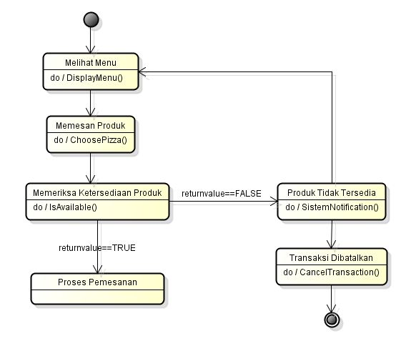

**State Diagram “PizzaController”  
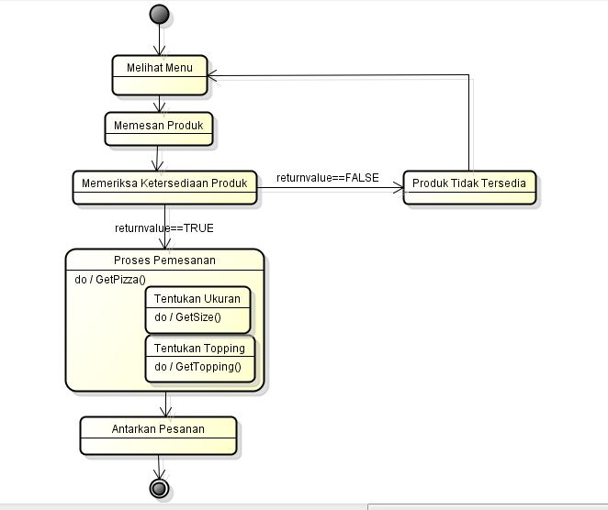  
State Diagram “Stok”**  
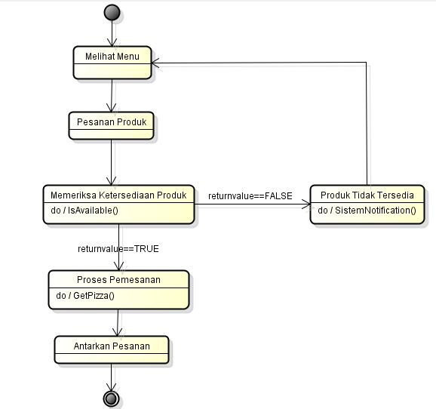

**State Diagram “Transaksi”**

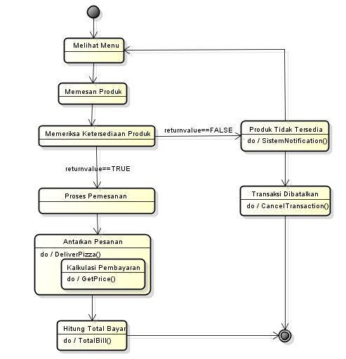

**Activity Diagram**

